## Task a:

**Code:**

t = -10:0.1:10;

y1 = zeros(size(t));

y2 = zeros(size(t));

for i = 1:length(t)

if t(i) < 0

y1(i) = 0;

elseif t(i) >= 0

y1(i) = (exp(-b*i)/(b-a))*(exp(i*(b-a))-1);

end

end

for i = 1:length(t)

if t(i) < 0

y2(i) = 0;

elseif t(i) >= 0

y2(i) = i*exp(-b*i);

end

end

subplot(2,1,1);

plot(t, y1, 'LineWidth', 2);

xlabel('t');

ylabel('x');

title('Alpha not equal to Beta');

grid on;

subplot(2,1,2);

plot(t, y2, 'LineWidth', 2);

xlabel('t');

ylabel('h');

title('Alpha equal to Beta');

grid on;

**Output:**

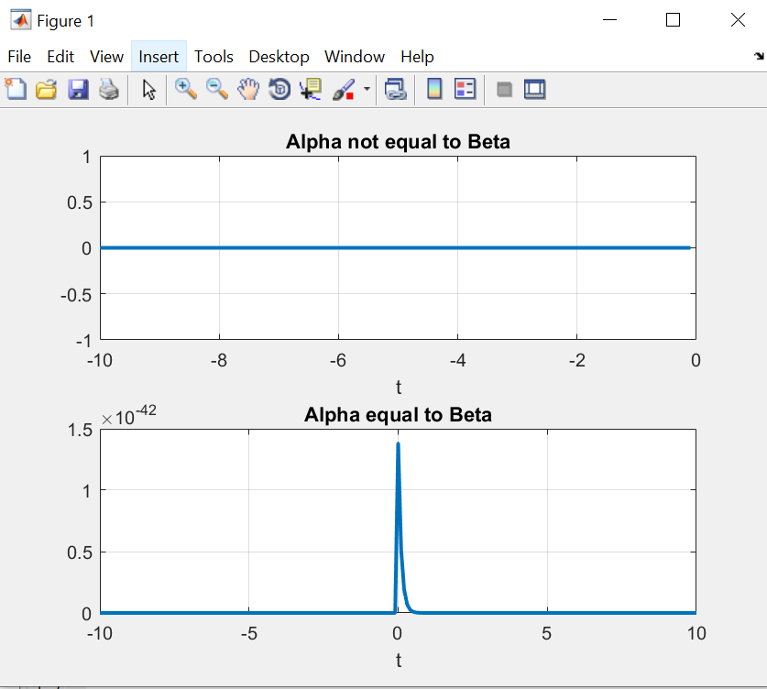

## Task b:

**Code:**

t = -10:0.1:10;

y1 = zeros(size(t)); % Initialize y with zeros

for i = 1:length(t)

if t(i) < 1

y1(i) = exp(2*i) * (-exp(-4) + 0.5 +0.5*exp(-10));

elseif t(i) >= 1 && t(i) < 3

y1(i) = -exp(2*(i-2))-exp(-2)+ 0.5 +0.5*exp(2*(i-5));

elseif t(i) >= 3 && t(i) < 6

y1(i) = 0.5*(exp(2*i-10)-exp(2));

else

y1(i)=0;

end

end

plot(t, y1, 'LineWidth', 2);

xlabel('t');

ylabel('x');

title('Output');

grid on;

**Output:**

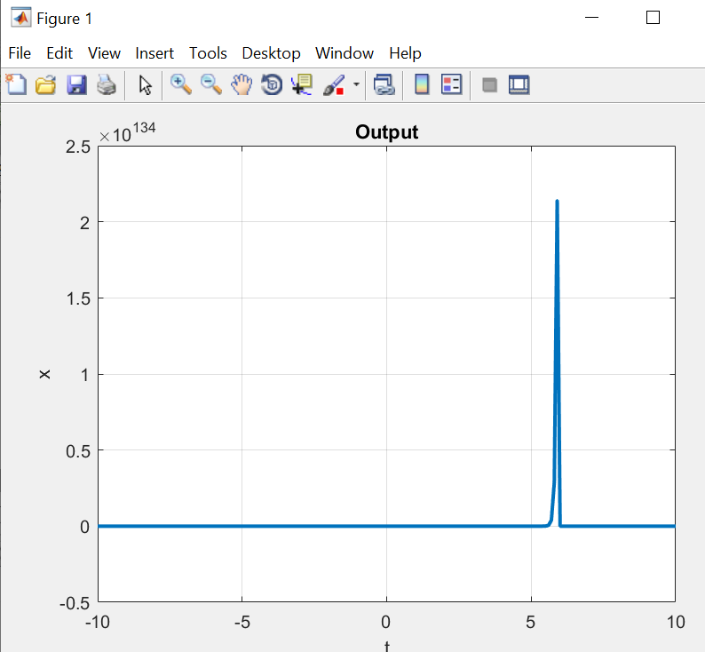

## Task c:

**Code:**

t = -10:0.1:10;

y1 = zeros(size(t));

for i = 1:length(t)

if t(i) < 1

y1(i) = 0;

elseif t(i) >= 1 && t(i) < 3

y1(i) = (2/pi)*(cos(pi*i)+1);

else

y1(i) = (-2/pi)*(cos(pi*i)+1);

end

end

plot(t, y1, 'LineWidth', 2);

xlabel('t');

ylabel('x');

title('Output');

grid on;

**Output:**

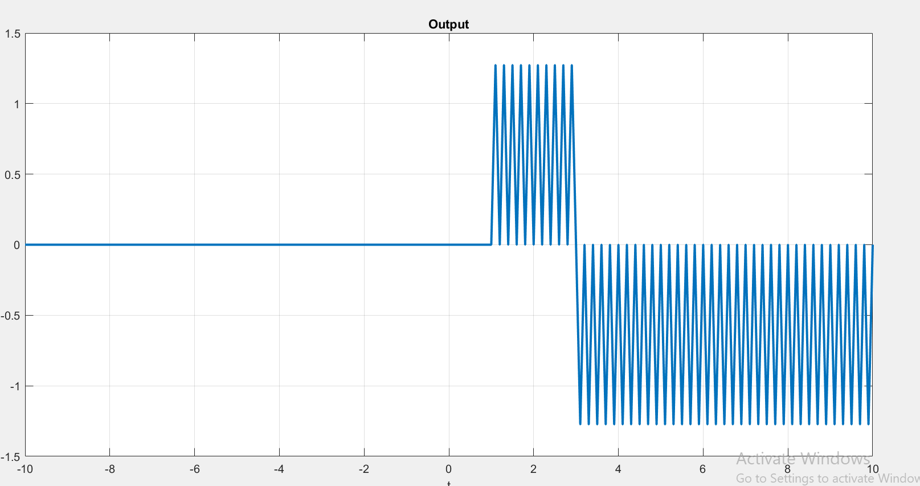

## Task d:

**Code:**

t = -10:0.1:10;

y1 = zeros(size(t));

a = 1;

b =1;

for i = 1:length(t)

y1(i) = a*i+b;

end

plot(t, y1, 'LineWidth', 2);

xlabel('t');

ylabel('x');

title('Output');

grid on;

**Output:**

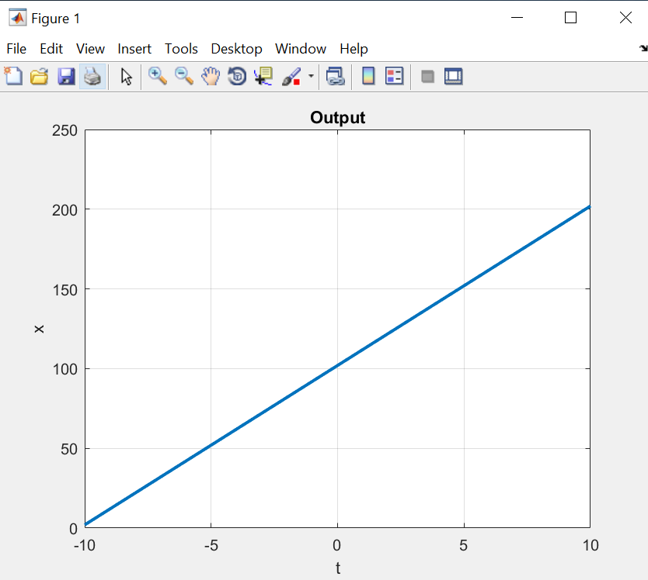

## Task e:

**Code:**

t = -10:0.1:10;

y1 = zeros(size(t));

for i = 1:length(t)

if t(i) > 0.5 && t(i) <1.5

y1(i) = (-i +2.5).^2 -0.5;

elseif t(i) >= 1.5 && t(i) < 2.5

y1(i) = 0.5 - (-i+2.5).^2;

elseif t(i) >= 2.5 && t(i) < 3.5

y1(i) = -0.5 + (-i+3.5).^2;

elseif t(i) >= 3.5 && t(i) < 4.5

y1(i) = 0.5 - (-i+4.5).^2;

elseif t(i) >= 4.5 && t(i) < 5.5

y1(i) = -0.5 + (-i+5.5).^2;

elseif t(i) >= 5.5 && t(i) < 6.5

y1(i) = 0.5 - (-i+6.5).^2;

elseif t(i) >= 6.5 && t(i) < 7.5

y1(i) = -0.5 + (-i+7.5).^2;

else

y1(i) = 0;

end

end

plot(t, y1, 'LineWidth', 2);

xlabel('t');

ylabel('x');

title('Output');

grid on;

**Output:**

